Sharvan Ram Kumaran

CSE-C

185001143

ASSIGNMENT 4- PATIENT MANAGEMENT SYSTEM

**Code:**

**Index.html:**

<!DOCTYPE html>

<html lang="en" dir="ltr">

<head>

<meta charset="utf-8">

<title>Login Page</title>

<link rel="stylesheet" href="login_style.css">

</head>

<body>

<h1>Login Here!</h1>

<div class="center">

<table class="center">

<form id="registration">

<tr>

<th><label for="username">Username: </label></th>

<td><input type="text" name="username" id="username" placeholder="Enter Username" required></td>

</tr>

<tr>

<th><label for="pwd">Password: </label></th>

<td><input type="password" name="pwd" id="pwd" placeholder="Enter Password" required ></td>

</tr>

<tr>

<td><input type="button" id="login" value="Login" onclick="myValidate()"></td>

</tr>

</form>

</table>

</div>

<script type="text/javascript">

function myValidate() {

if(document.getElementById("username").value==="admin" && document.getElementById("pwd").value==="admin"){

document.getElementById("username").value="";

document.getElementById("pwd").value="";

window.open("homepage.html");

}

else{

document.getElementById("username").value="";

document.getElementById("pwd").value="";

alert("Login Failed, enter the correct details");

document.getElementById("username").focus();

}

}

</script>

</body>

</html>

**Homepage.html:**

<!DOCTYPE html>

<html lang="en" dir="ltr">

<head>

<meta charset="utf-8">

<title>Home Page</title>

</head>

<body>

<h1>Patient Details</h1>

<a href="add.html">Add Record</a><br>

<a href="delete.html">Delete Record</a><br>

<a href="search.html">Search a Record</a>

</body>

</html>

**Add.html:**

<!DOCTYPE html>

<html>

<head>

<title>Patient Management System</title>

<meta charset="utf-8">

<link rel="stylesheet" href="add_style.css">

</head>

<body>

<h1>Add Patient</h1><br>

<table class="center">

<form name="regform" id="regform" action="http://localhost:8080/PMS/AddServlet" >

<tr>

<td><label for="name">Name: </label></td>

<td><input name="name" id="name" type="text" placeholder="Enter Name" required></td>

</tr>

<tr>

<td><label for="age">Age: </label></td>

<td><input name="age" id="age" type="number" placeholder="Enter Age" required></td>

</tr>

<tr>

<td><label for="id">ID: </label></td>

<td><input name="id" id="id" type="number" placeholder="Enter ID"required></td>

</tr>

<tr>

<td><label >Gender: </label></td>

<td><input id="male" type="radio" value="Male" name="gender"><label for="male">Male</label>

<input id="female" type="radio" value="Female" name="gender"><label for="female">Female</label>

<input id="other" type="radio" value="Other" name="gender"><label for="other">Other</label>

</td>

</tr>

<tr>

<td><label for="address">Address: </label></td>

<td><textarea name="address" id="address" placeholder="Enter full address" required></textarea></td>

</tr>

<tr>

<td><label for="status">Marital Status: </label></td>

<td><select name="status" id="status">

<option value="none"></option>

<option value="Married">Married</option>

<option value="single">Single</option>

</select></td>

</tr>

<tr>

<td><label for="dov">Date of Visit: </label></td>

<td><input name="dov" id="dov" type="date" placeholder="dd/mm/yyyy"></td>

</tr>

<tr>

<td><input type="submit" value="Submit" id="submit" ></td>

<td><input type="reset" value="Reset" id="reset"></td>

</tr>

</form>

</table>

</body>

</html>

**Delete.html:**

<!DOCTYPE html>

<html lang="en" dir="ltr">

<head>

<meta charset="utf-8">

<title>Delete Patient</title>

<link rel="stylesheet" href="add_style.css">

</head>

<body>

<h1>Delete Patient</h1><br>

<table class="center">

<form class="center" action="http://localhost:8080/PMS/DeleteServlet">

<tr>

<td><label for="id">ID: </label></td>

<td><input type="number" name="id" id="id" placeholder="Enter ID" required></td>

</tr>

<tr>

<td><input type="submit" value="Submit" id="submit" ></td>

<td><input type="reset" value="Reset" id="reset"></td>

</tr>

</form>

</table>

</body>

</html>

**Search.html:**

<!DOCTYPE html>

<html lang="en" dir="ltr">

<head>

<meta charset="utf-8">

<title>Search Patient</title>

<link rel="stylesheet" href="add_style.css">

</head>

<body>

<h1>Search Patient</h1><br>

<table class="center">

<form class="center" action="http://localhost:8080/PMS/SearchServlet">

<tr>

<td><label for="id">ID: </label></td>

<td><input type="number" name="id" id="id" placeholder="Enter ID" required></td>

</tr>

<tr>

<td><input type="submit" value="Submit" id="submit" ></td>

<td><input type="reset" value="Reset" id="reset"></td>

</tr>

</form>

</table>

</body>

</html>

**AddServlet.java:**

import java.util.*;

import jakarta.servlet.http.*;

import jakarta.servlet.*;

import java.io.*;

import java.sql.*;

public class AddServlet extends HttpServlet {

public void doGet(HttpServletRequest request, HttpServletResponse response) throws ServletException, IOException {

PrintWriter out = response.getWriter();

String age = request.getParameter("age");

String id = request.getParameter("id");

String name = request.getParameter("name");

String gender = request.getParameter("gender");

String addr = request.getParameter("address");

String status = request.getParameter("status");

String dov = request.getParameter("dov");

try{

Class.forName("com.mysql.jdbc.Driver");

Connection con=DriverManager.getConnection("jdbc:mysql://localhost:3306/PATIENT_DETAILS","root","crashgoku17");

Statement stmt=con.createStatement();

String sql = "INSERT INTO PATIENT_DETAILS VALUES(?, ?, ?, ?, ?, ?, ?)";

PreparedStatement pst = con.prepareStatement(sql);

pst.setString(1, name);

pst.setInt(2, Integer.parseInt(age));

pst.setInt(3, Integer.parseInt(id));

pst.setString(4, gender);

pst.setString(5, addr);

pst.setString(6, status);

pst.setString(7, dov);

pst.executeUpdate();

pst.close();

con.close();

RequestDispatcher rd = request.getRequestDispatcher("/homepage.html");

rd.forward(request, response);

} catch (SQLException sql) {

sql.printStackTrace();

out.println(sql);

} catch (Exception e) {

e.printStackTrace();

out.println(e);

}

}

}

**DeleteServlet.java:**

import java.util.*;

import jakarta.servlet.http.*;

import jakarta.servlet.*;

import java.io.*;

import java.sql.*;

public class DeleteServlet extends HttpServlet {

public void doGet(HttpServletRequest request, HttpServletResponse response) throws ServletException, IOException {

PrintWriter out = response.getWriter();

String id = request.getParameter("id");

try {

Class.forName("com.mysql.jdbc.Driver");

Connection conn = DriverManager.getConnection("jdbc:mysql://localhost:3306/PATIENT_DETAILS","root","crashgoku17");

Statement stmt = conn.createStatement();

String sql = "DELETE FROM PATIENT_DETAILS WHERE ID = ?";

PreparedStatement pst = conn.prepareStatement(sql);

pst.setInt(1, Integer.parseInt(id));

pst.executeUpdate();

pst.close();

conn.close();

RequestDispatcher rd = request.getRequestDispatcher("/homepage.html");

rd.forward(request, response);

} catch (SQLException sql) {

sql.printStackTrace();

out.println(sql);

} catch (Exception e) {

e.printStackTrace();

out.println(e);

}

}

}

**SearchServlet.java:**

import java.io.*;

import java.util.*;

import jakarta.servlet.*;

import jakarta.servlet.http.*;

import java.sql.*;

public class SearchServlet extends HttpServlet{

public void doGet(HttpServletRequest request, HttpServletResponse response) throws ServletException, IOException {

PrintWriter out = response.getWriter();

String pid = request.getParameter("id");

try {

Class.forName("com.mysql.jdbc.Driver");

Connection conn = DriverManager.getConnection("jdbc:mysql://localhost:3306/PATIENT_DETAILS","root","crashgoku17");

Statement stmt = conn.createStatement();

String sql = "select * from PATIENT_DETAILS where ID = " + Integer.parseInt(pid);

ResultSet rs = stmt.executeQuery(sql);

if(rs.next()) {

response.setContentType("text/html");

int id = rs.getInt("id");

int age = rs.getInt("age");

String name = rs.getString("name");

String gender = rs.getString("gender");

String addr = rs.getString("address");

String status = rs.getString("mstatus");

String dov = rs.getString("dov");

out.println("Name:" + name + "<br>");

out.println("ID:" + id + "<br>");

out.println("Age:" + age + "<br>");

out.println("Gender:" + gender + "<br>");

out.println("Address:" + addr + "<br>");

out.println("Marital Status:" + status + "<br>");

out.println("Date of visit:" + dov + "<br>");

out.println("<br><br>");

}

else {

out.println("No such record found<br>");

}

stmt.close();

conn.close();

} catch (SQLException sql) {

sql.printStackTrace();

out.println(sql);

} catch (Exception e) {

e.printStackTrace();

out.println(e);

}

}

}

**Login_style.css:**

html {

background: url(building.jpg) no-repeat center center fixed;

-webkit-background-size: cover;

-moz-background-size: cover;

-o-background-size: cover;

background-size: cover;

}

h1{

text-align: center;

font-family: menlo;

color: LightSalmon;

}

div{

height: auto;

width: 30%;

background-color: powderblue;

border-radius:16px;

}

.center{

margin: auto;

}

input[type="text"],

input[type="password"]{

width: 50%;

padding: 6px;

border: 1px solid #cccc;

border-radius: 5px;

margin: 10px;

font-family: menlo;

text-align: center;

}

table{

text-align: center;

}

tr,th{

font-family: menlo;

color: white;

text-align: center;

}

label{

font-family: menlo;

font-size: 15;

color: MidnightBlue;

}

input[type=submit] {

background-color: #4CAF50;

width:70%;

color: white;

padding: 5px;

border-radius: 16px;

font-family: menlo;

text-align: center;

}

input[type=reset] {

background-color: red;

width:50%;

color: white;

padding: 5px;

border-radius: 16px;

font-family: menlo;

}

**Add_style.css:**

html {

background: url(daybeach.jpg) no-repeat center center fixed;

-webkit-background-size: cover;

-moz-background-size: cover;

-o-background-size: cover;

background-size: cover;

}

h1{

text-align: center;

font-family: menlo;

color: GoldenRod;

}

.center{

margin: auto;

}

table{

text-align: center;

}

tr,th{

font-family: menlo;

color: white;

text-align: center;

}

label{

font-family: menlo;

font-size: 15;

color: OliveDrab;

}

input[type=submit] {

background-color: #4CAF50;

width:60%;

color: white;

padding: 5px;

border-radius: 16px;

font-family: menlo;

text-align: center;

}

input[type=reset] {

background-color: red;

width:50%;

color: white;

padding: 5px;

border-radius: 16px;

font-family: menlo;

}

input[type="text"],

input[type="number"],

input[type="date"]{

width: 50%;

padding: 6px;

border: 1px solid #cccc;

border-radius: 5px;

margin: 10px;

font-family: menlo;

text-align: center;

}

textarea{

font-family: menlo;

border-radius: 16px;

}

**Web.xml:**

<web-app>

<servlet>

<servlet-name>AddServlet</servlet-name>

<servlet-class>AddServlet</servlet-class>

</servlet>

<servlet-mapping>

<servlet-name>AddServlet</servlet-name>

<url-pattern>/AddServlet</url-pattern>

</servlet-mapping>

<servlet>

<servlet-name>DeleteServlet</servlet-name>

<servlet-class>DeleteServlet</servlet-class>

</servlet>

<servlet-mapping>

<servlet-name>DeleteServlet</servlet-name>

<url-pattern>/DeleteServlet</url-pattern>

</servlet-mapping>

<servlet>

<servlet-name>SearchServlet</servlet-name>

<servlet-class>SearchServlet</servlet-class>

</servlet>

<servlet-mapping>

<servlet-name>SeachServlet</servlet-name>

<url-pattern>/SearchServlet</url-pattern>

</servlet-mapping>

</web-app>

**OUTPUT:**

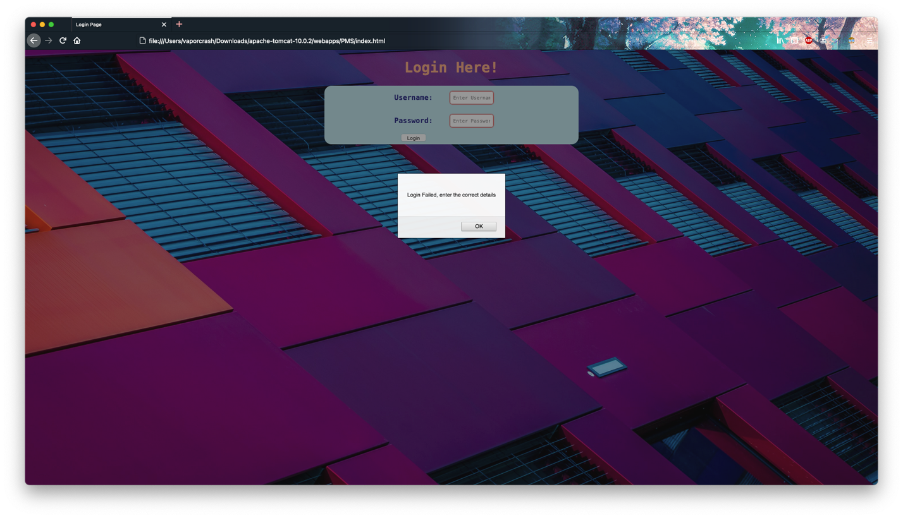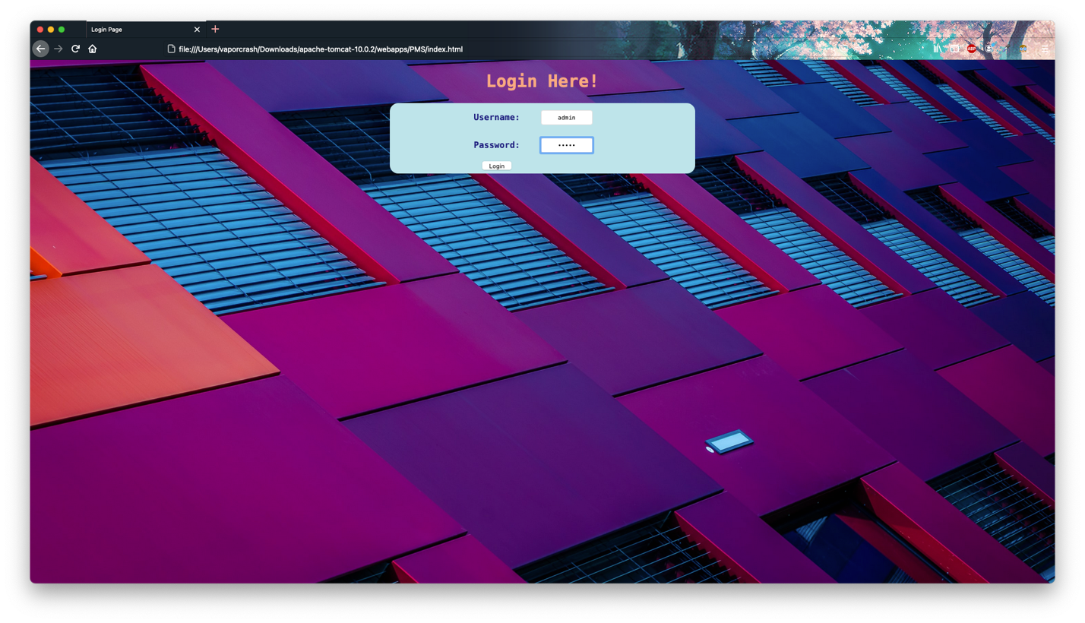

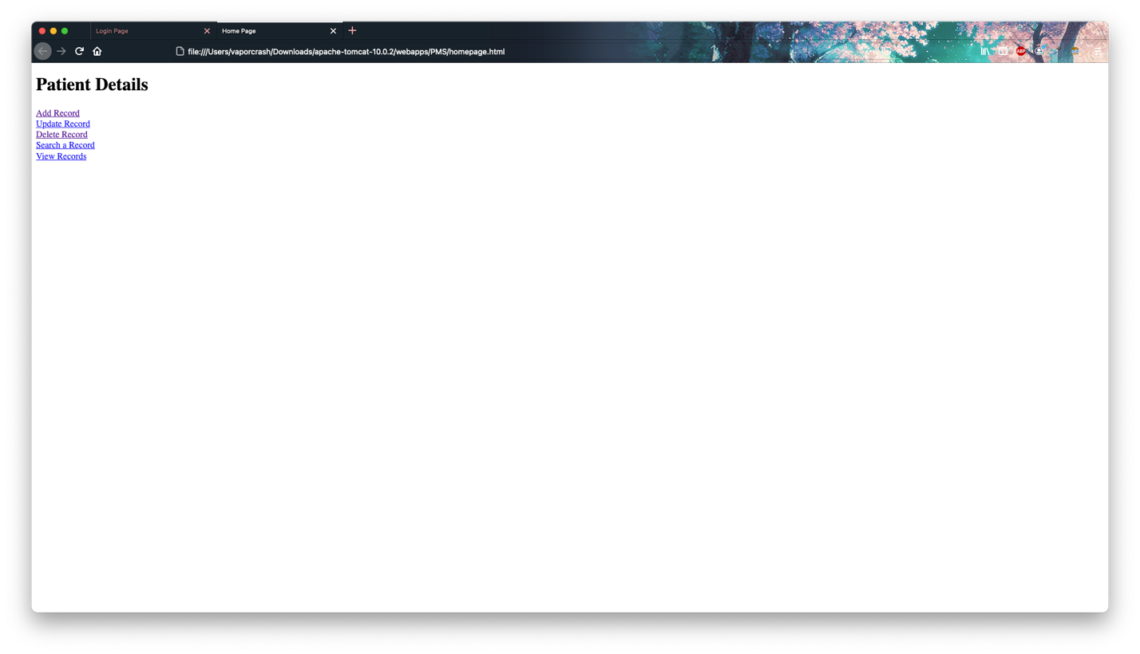

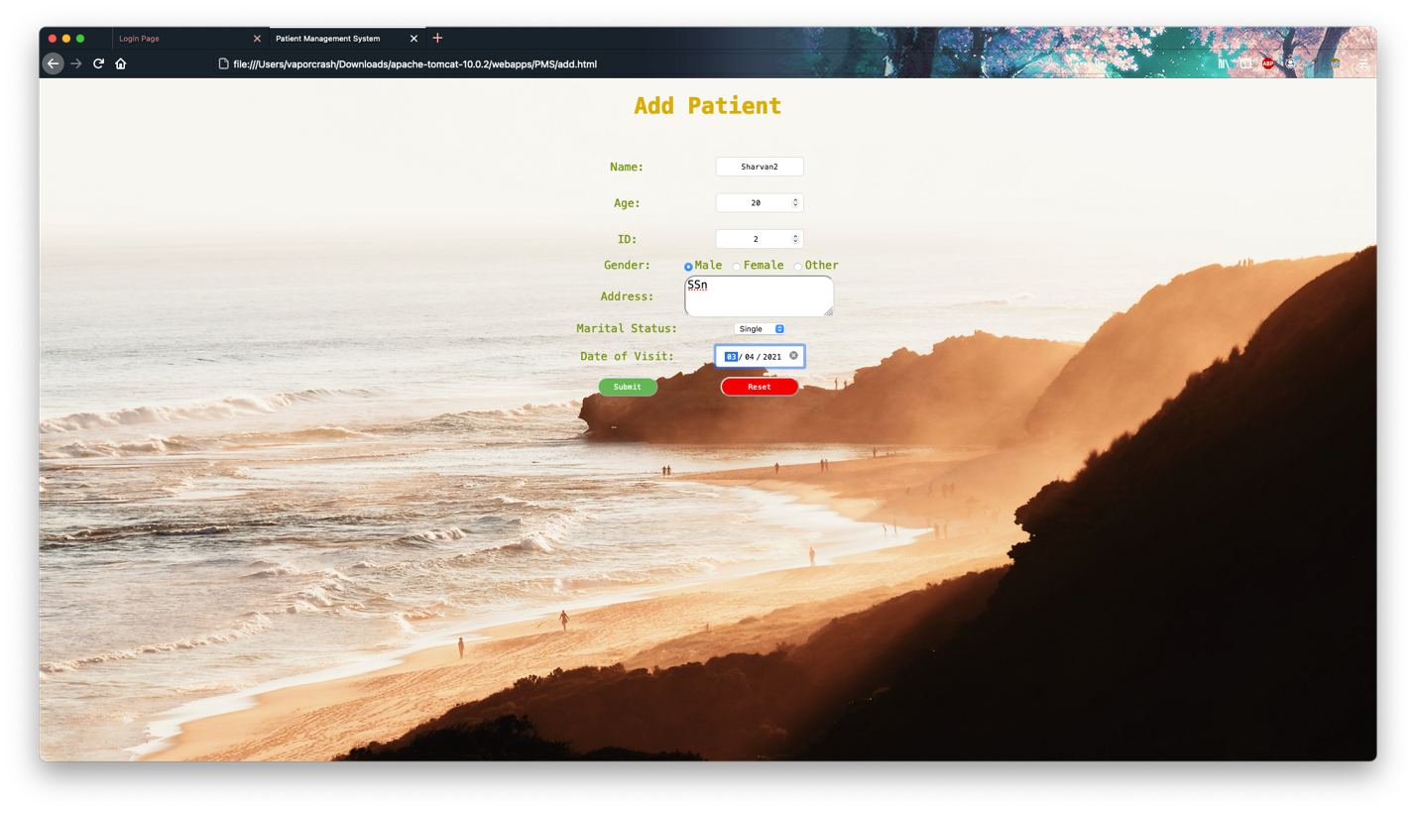

After adding:

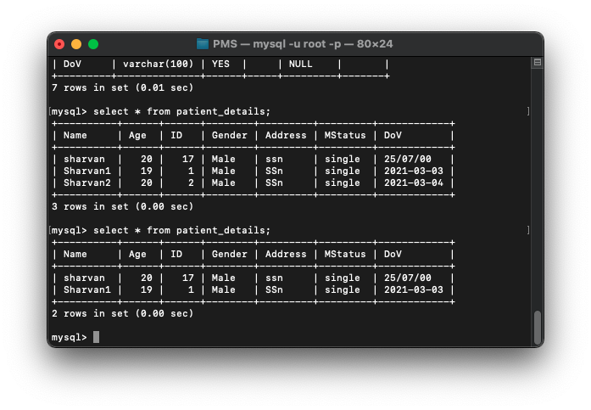

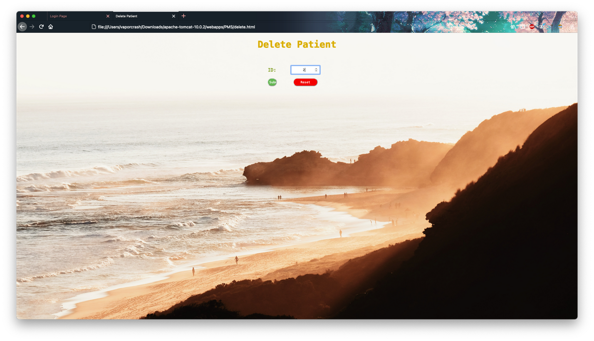

After Deleting:



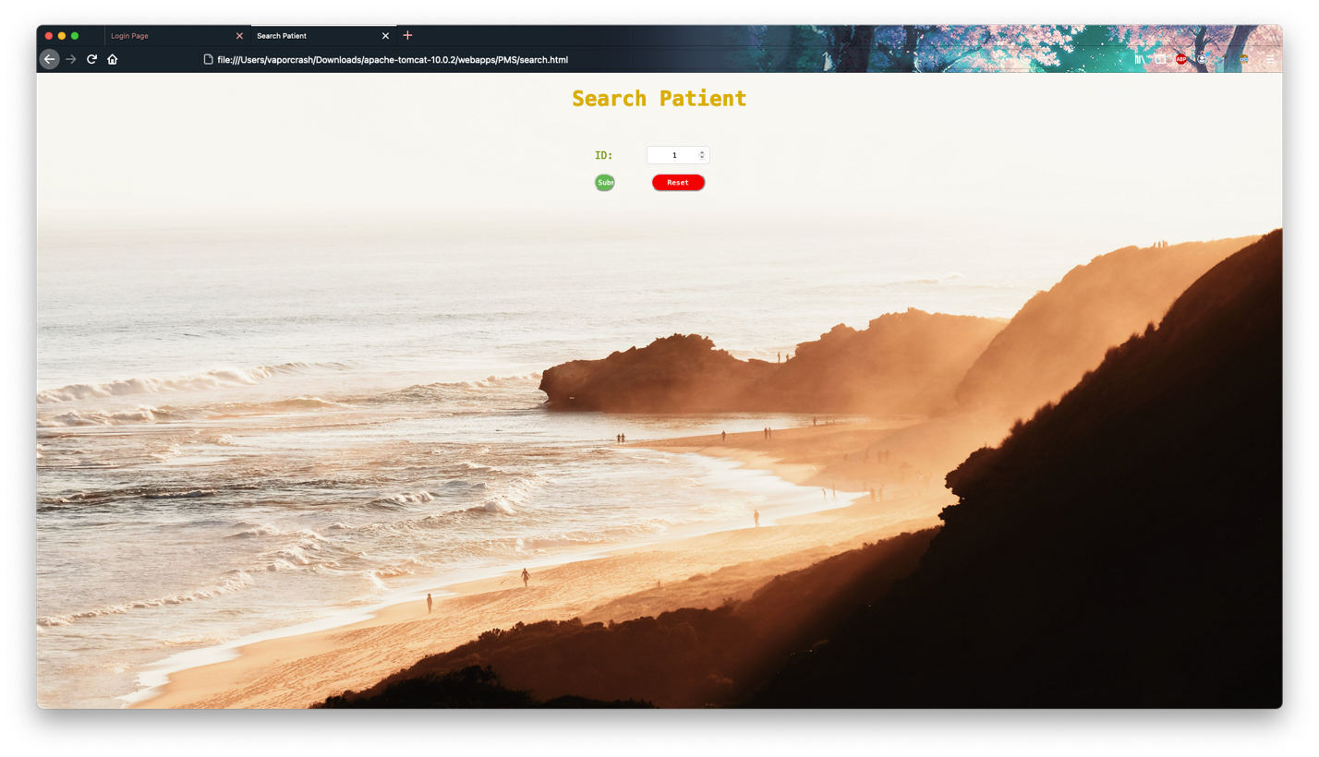

**Learning Objective:**

Given System was built using HTML and servlets.